The Sandbox Strategy Workshop: how the different styles build, ________ and collaborate.

TODAY YOU WILL LEARN how God has designed you and others and unveil the ________ of each style; and before our time is up, you will learn how to improve _________ with those you work and live with!

EPHESIANS 2:10
¹⁰ For we are his workmanship, created in Christ Jesus for good works, which God prepared beforehand, that we should walk in them.
PHILIPPIANS 2:13
13 for it is GOD who WORKS IN YOU both to will and to do for His good pleasure.

Who am I? Why am I here?
"...know that the Lord, He is God. It is He who has made us, and not we ourselves." "We are His people."
The KEY to our own _________ begins to unlock when we come to Jesus and receive Him into our lives.

WHOSE STORY AM I IN?
John 10:10,
(1) The thief does not come except to steal, and to kill and to destroy
(2) I have come that they may have life, and that they may have it more abundantly.

WE ARE CALLED TO A JOURNEY OF PURSUING GOD'S WILL AND THE DEVELOPMENT OF CHRIST-LIKE ___________.
GOD WILL WORK ____ _______ before He will WORK ________ _____

When God “knit you together,” he wove in your unique _________

strengths, weaknesses, giftings, talents, etc. God created you to be you

Be yourself. Be true to who God designed...

My identity is not in what I do. It is _____ I am in the weaving of God’s hands.

Specifically It is Who I am in Christ!

WHEN WE FIND OURSELVES IN JESUS ' STORY, HE GIVES US A PART IN THE STORY AND HELPS US TO LIVE IT OUT. Have you found your part in the story?

____________________________

FILL IN WORDS: connect - strengths - communication - identity - character - in you - through you - personality - who

There is a way to recognize patterns of behavior that help us see people are different; they are predictably different.

Once you learn the DISC styles, you can recognize personality characteristics, __________, and strengths. You will also recognize blind spots within that style.
God wants me to ACCEPT my design:

Three problems can occur when we don’t embrace who God made us to be.
1. We __________ ourselves with others, which leaves us feeling either jealous, resentful, or dissatisfied. On the flip side, if we think we are doing better than someone else, or think our personality is better, we can feel arrogant or proud.
2. When we don’t _____________ our design and try to be like others, it increases our stress, has us saying yes to too many opportunities that do not fit our God-given design, and overall decreases our satisfaction in life. We conform ourselves and try to be someone we are not.
3. We ________ ourselves (gifts and personality) onto others and expect everyone else to act, think, behave, and feel like we do.
There are different kinds of serving in the church, but it is the same Lord we are serving. 1 Corinthians 12:5

WHAT SHAPES OUR PERSONALITY?
Each person’s personality and behavior are shaped by three main areas.
1. HEREDITY - From birth, there are distinct patterns of behavior.
2. ___________ - Our environment will impact our style. In fact, life
experiences in our developmental years (especially emotionally charged ones) can have a big impact on our personality style.
3. _____________ - There are role models in our lives who teach us what is valuable, or who may even reward us for certain behaviors in order to reinforce those behaviors within us.
Each of these factors contributes to the makeup of who we are!

When we look at it from a DISC perspective,
D’s and I’s are more ____________. They like meeting new people in church.
C’s and S’s are more _________.

They hope the visitor doesn’t make eye contact or try to talk to them.
_______________________
FILL IN WORDS: personality - who - patterns - compare — understand — project
environment - role models - outgoing - reserved

When we become aware of the pattern of how they _________, we not only know what kind of communication to expect _______ them; we also know how to best prepare _______, interact WITH, and respond TO them so that we can have a successful connection!

Let’s look at two basic behavior characteristics.
Are you outgoing or reserved?

Are you people-oriented or task-oriented?

D stands for ___________. When someone has significant characteristics in this style, they typically look to dominate situations.

I is for _____________. This style is characterized by a person's influence on others through how they express themselves.

S is for __________ and _________ . These are just two of the incredible behaviors this style brings to any team.

C is for _________. They place significant emphasis on ensuring compliance as they deliver results.

______________________

FILL IN WORDS: communicate - from - for - dominate - influencing - steady or supportive - compliant

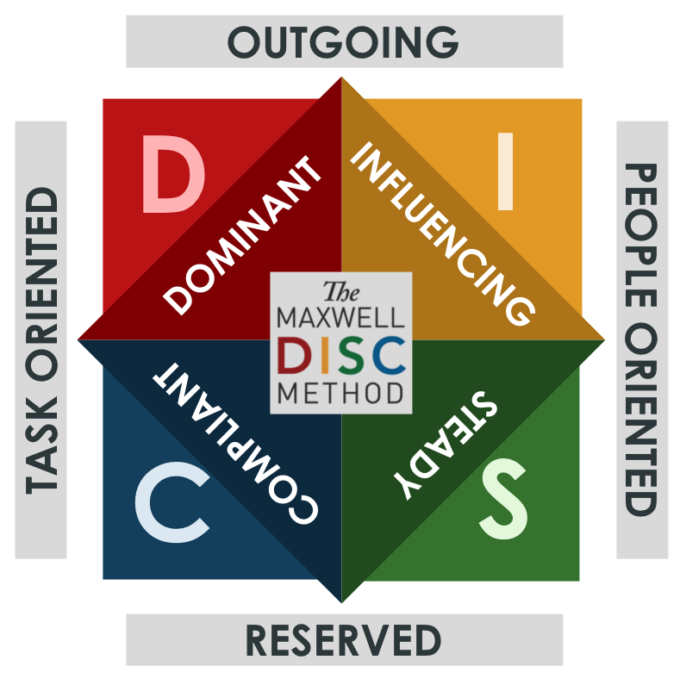

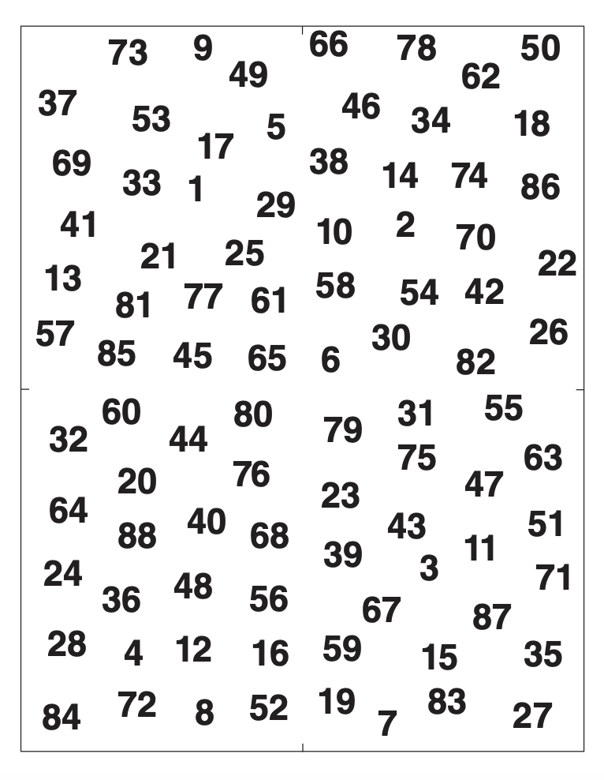

D STLYE IS ACTIVE AND MULTITASKS. 3% WORLD.

D’s…Are driven by _________ — Will easily try to take control — Embrace any change that will help them get results — Are very comfortable responding to direct confrontation — Treasure loyalty — Want results — Make decisions quickly — bold, even aggressive — Thrive in an environment that offers up resistance.

Here are some more strengths of the D Style: Bold — ________ — Decisive — Productive Strong-willed — Independent — Positive Persistent — Excels in emergencies — Goal-oriented Motivates others to action — ______-_______ — Values business-related socializing — Comfortable leading — Thrives on resistance

The I Style seeks a ________ Environment and is very Active. 11 % WORLD.

I’s are Relationship-oriented — Emotional and animated — Great ____________

Encouragers — Comfortable in large groups — Talkative — Optimistic — Encouraging
Here are some additional I-style Strengths. Persuasive — Generous — Charismatic — Enthusiastic — Friendly — Talkative — Comfortable in the spotlight — Social — Spontaneous — Creative — Inspires others — Charming — Likable — _____ — Optimistic

The S Style seeks a ______ Environment and is very Loyal. 69% WORLD

S’s are…Easygoing and agreeable — Evenly paced — Good ______ — Compassionate — Peaceful — Relationship-focused — Reliable — Loyal — Systematic — Mediators — Process-oriented — Sentimental

Here are some additional S-style Strengths. Hard worker — Team player —Stable — _____ — Secure — Sentimental — Saver — Reserved — Close friendships — Faithful — Finds the easy way — Mediates — Routine-oriented — Supportive

The C Style seeks an Environment that Honors ______ and Facts. 17 % WORLD

C’s are…Compliance with the ______ — Focused —Conscientious — Accurate —

Detail-oriented — Perfectionists — Analytical problem solvers — Organized — Scheduled — Quality-focused — Precise

Here are some additional Strengths of the C style. Analytical — Genius-prone — Self-sacrificing — Idealistic — High quality work — ______ and organized —Logical —Persistent —Planner —Finishes what they start — Data-driven — Gathers facts —Deep thinker — Serious — Accurate

Christine _____ Style

Sarah ________Style

Ion __________Style

Dan _________Style
FILL IN WORDS:
(D) Authority — Confident — Results-Focused
(I) Friendly — Storytellers — Fun
(S) Team — Listeners — Steady
(C) Logic — Rules — Orderly
BLIND SPOTS. Each of us has _____ _____. We can’t see what it is like to be on the other side of us. Each of our incredible strengths, if used incorrectly OR _______, can be a blind spot. We all have blind spots, things that others can see that we can’t see.

PERCEPTIONS. ANOTHER PERSONS PERCEPTION IS THEIR _________.
WE JUDGE OURSELVES BY OUR INTENTIONS. WE JUDGE OTHERS BY THEIR ACTIONS.

Potential Blind Spots and Perceptions with each style.

____________________________

D STYLE AT TIMES MAY BE

Argumentative — A Workaholic — Inconsiderate — Insensitive — Opinionated — Dominating — Controlling — Impatient — Non-Apologetic — Uptight — Confrontational

GREATEST FEAR: BEING TAKEN ________ ___

SECRET FUEL: GETTING THINGS DONE

____________________________

I STYLE AT TIMES MAY BE

Undisciplined — Forgetful — Disorganized — Not Listening — Overcommitted —

Not Following Through — Too Positive — Wasting Time — Distracted — Talkative Impulsive — Naive - Seeking the Spotlight

GREATEST FEAR: __________ AND LOSS OF APPRECIATION

SECRET FUEL: HAVING FUN

____________________________
S STYLES AT TIMES MAY BE
Laid Back — Avoiding — Resistant to Change and Confrontation — At a slow but Deliberate Pace — Possessive — Skeptical — Slow to Start — Indecisive — Hesitant to Say No — Not Speaking Up

GREATEST FEAR: LOSS OF _________ AND CONFLICT
SECRET FUEL: PEACE AND HARMONY

____________________________
C STYLE AT TIMES MAY BE
Moody — Working Along — Critical — Overanalyzing — Anti-Social — A Perfectionist — Rigid — Avoiding Risk — Legalistic — Too Much in the Details — Distant

GREATEST FEAR: BEING CRITICIZED AND _____________
SECRET FUEL: QUALITY ANSWERS — VALUE — BEING CORRECT

FILL IN WORDS: blind spots — misused — reality — advantage of — rejection — security — confrontation

HOW TO CONNECT WITH OTHER STYLES:

AS A D, Proverbs 15:1, A gentle answer turns away wrath, but a harsh word stirs up anger.

WITH ANOTHER D: Understand each other’s boundaries of authority, and if you have expertise. If you have mutual respect, you will experience great results with little or no conflict.

WITH AN I: Lighten up in their presence and make the work enjoyable. Remember to smile! Negotiate commitments and goals with a degree of flexibility as to how they are completed.

WITH AN S: Avoid being confrontational. Recognize their great work. Use a friendly, conversational tone. Be relaxed in your approach.

WITH A C: Provide facts and details. Expect and answer questions. Stop looking at their questions as if they are questioning you; they are merely gathering information. Allow them time to process their thoughts before responding.

____________________________
AS AN I, Proverbs 29:25 (NIV) Fear of man will prove to be a snare, but whoever trusts in the Lord is kept safe. Matthew 6:24 (NIV) No one can serve two masters.

WITH A D: Be Direct. Get to the point quickly. Deal with issues in a straightforward way. Negotiate commitments and goals and deliver as promised.

WITH ANOTHER I: Be your friendly self. Acknowledge each other’s accomplishments. Be sure to listen and follow up on the details.

WITH AN S: Slow your pace. Be easygoing and congenial, and show appreciation for them as a person. Respect their strengths of organization and systems, and allow them time to plan.

WITH A C: Do not be overly chatty. Prepare facts in advance and be sure they are accurate. Expect questions and respond with answers when necessary. Give them time to make a decision. In a conversation, stay on topic and pause to give them time to provide a reflective answer.

AS AN S, 1 Thessalonians 2:4 (NIV) …we speak as those approved by God to be entrusted with the gospel. We are not trying to please people but God, who tests our hearts.

WITH A D: Be more assertive than is comfortable for you. Deal with issues in a straightforward way and quicken your normal pace. Focus on facts more than feelings. Use your ability to systematize to deliver results efficiently.

WITH AN I: Be friendly and complimentary and listen to their ideas. Recognize their accomplishments. Share in their excitement.

WITH AN S: Express appreciation for them and make it a friendly atmosphere. Foster the mutual trust and team approach you both enjoy. Collaborate on planning systems and technology to create efficiencies.

WITH A C: Enter through the door of logic and not relationship, so your feelings don’t get hurt. Slow your pace and communicate on one topic at a time. Do your homework and bring facts. Expect them to ask questions so they can gather more information, and provide them time to evaluate data before making a decision.

____________________________
AS A C, John 8:36 NIV If the Son sets you free, you will be free indeed

WITH A D: Be direct and brief, and focus on results. Communicate with bullet point emails. Negotiate commitments and goals. Respect their need to work fast while ensuring the work is done right.

WITH AN I: Be friendly, complimentary, and interactive. Talk about something personal before business. It is better to have four 10-minute discussions on four different topics than one 40-minute discussion covering all four.

WITH AN S: Focus on the friendship first and tasks second. Express appreciation for what they do. Establish a relationship before expecting trust. Allow their people focus to complement your task focus to create balance within the team.

WITH A C: Enjoy trading facts and gathering additional information. Appreciate their focus. Ask for their expert opinion or input and collaborate to solve challenging problems that require analysis. Practice agreeing to disagree in some areas where you each have a valid argument.

The key is using this to help us collaborate, connect, and communicate effectively.

Identify one thing that really sticks in your mind from all I have shared today.
What is your take-home?

What is the one thing you have learned, or will do differently, as a result of what we have covered today?

Write down five bullet points about yourself that really express who you are in your style.
1.
2.
3.
4.
5.

